1-6-16

McComb named senior vice provost for Academic Affairs at OSU

By Mark Floyd, 541-737-0788, mark.floyd@oregonstate.edu
Source: Sabah Randhawa, 541-737-2111, Sabah.Randhawa@oregonstate.edu

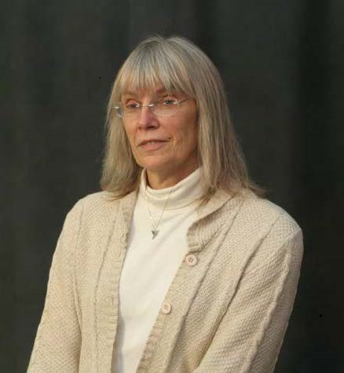
CORVALLIS, Ore. – Brenda McComb, a longtime Oregon State University faculty member and dean of the Graduate School since 2011, has been named senior vice provost for Academic Affairs at OSU.

Before being selected to head the Graduate School, McComb led the Department of Forest Ecosystems and Society in Oregon State’s College of Forestry.

As senior vice provost, McComb will support Provost and Executive Vice President Sabah Randhawa in matters related to faculty development, curricular operations, assessment and accreditation, strategic plan implementation, academic capacity planning, academic initiatives and special projects. She also will serve on the OSU President’s Cabinet and Provost’s Council.

Among the primary responsibilities for the senior vice provost:
- Leadership and coordination of faculty matters, including shaping faculty hiring, support and development of OSU faculty;
- Oversight of curriculum matters, including curriculum development and review;
- Liaison with the Northwest Commission on Colleges and Universities and the Higher Education Coordination Curriculum;
- Oversight of institutional planning and research.

“Brenda McComb has invaluable experience both as a faculty member and as an administrator working with faculty in creating an environment that supports exceptional teaching, research and outreach,” Randhawa said. “Brenda provided exceptional leadership to the Graduate School, which is better-positioned now to meet the needs of our graduate students and support graduate faculty.”

McComb’s career began at the University of Kentucky’s Department of Forestry. She joined the Oregon State faculty, with joint appointments in forestry and fisheries and wildlife, in 1987. After nearly a decade at Oregon State, McComb left to become head of the Department of Natural Resources Conservation at the University of Massachusetts, and returned to OSU in 2009 to head the Department of Forest Ecosystems and Society.

In addition to her roles as department head and dean of the Graduate School, McComb has served as a founding member of the Oregon State University Board of Trustees since 2012.

McComb will begin her new position on Jan. 11. The appointment of senior vice provost is typically made for five years, though the length of appointment is at the discretion of OSU provost. McComb succeeds Rebecca Warner, who is returning to teaching and research in the College of Liberal Arts.

Randhawa said a leadership succession plan for the Oregon State University Graduate School will be forthcoming.

-30-

